Phase IV: Process Automation

**AURA EVENTS & SPONSOR**:  
College Events & Sponsor Management

**Validation Rules (Data Quality Enforcement)**

* **Explanation:** Simple rules were implemented to prevent users from saving bad data, enforcing data integrity at the time of record creation or update.
* **Salesforce Path:** Setup → Object Manager → Select Object → Validation Rules
* **Procedure & Configuration:**
  + **Rule 1 (Date Integrity):** Prevents the End Date from being before the Start Date on the **Event** object.
  + **Rule 2 (Sponsor Finances):** Prevents setting **Sponsor** Status to "Closed Won" if the **Sponsorship Amount** is blank.
  + **Rule 3 (Event Activation):** Prevents setting **Event** Status to "Active" if the **Venue** field is empty.
  + **Rule 4 (Vendor Date):** Prevents entering a **Vendor** Payment Due Date that is in the past.

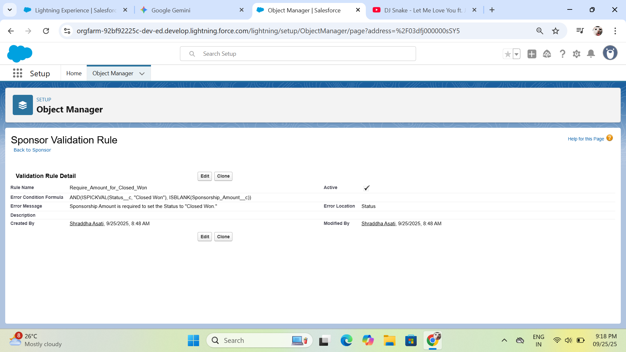

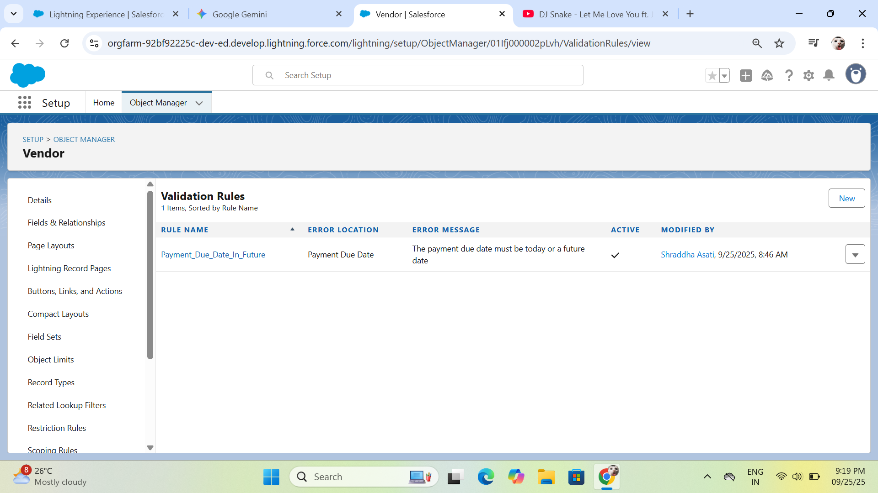

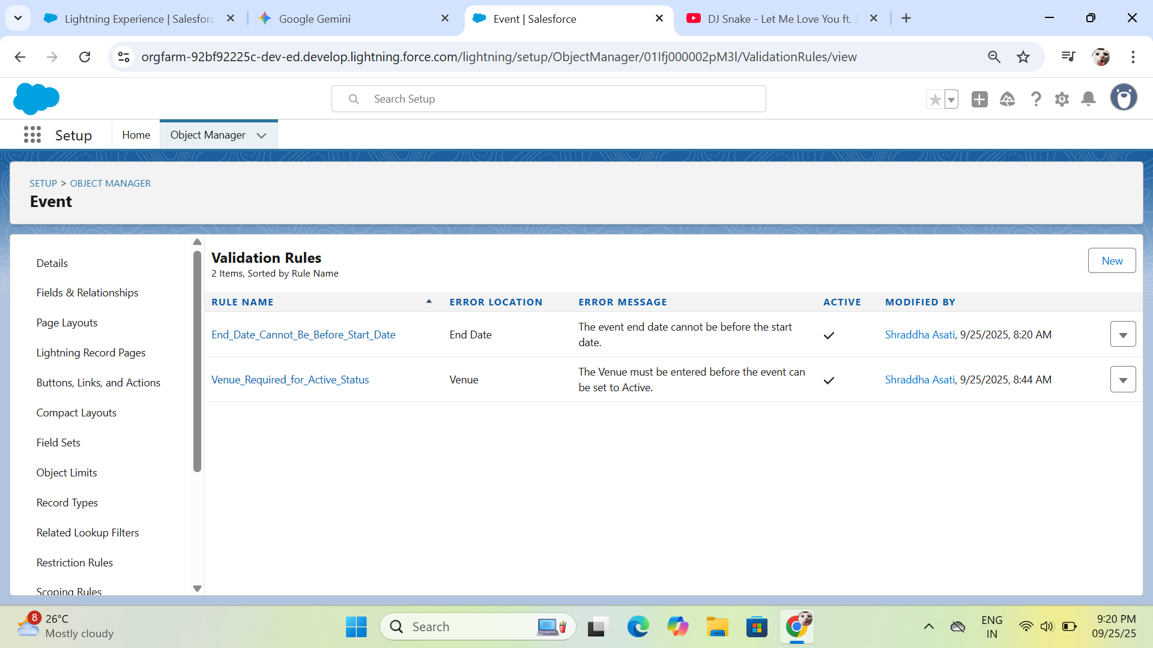

**Flow Builder (Core Business Logic)**

* **Explanation:** Flows were built to automate key cross-functional processes, replacing manual steps and managing time-sensitive notifications. **Flow Builder** was used instead of older tools (Workflow Rules, Process Builder).
* **Salesforce Path:** Setup → Quick Find → Flows
* **Procedure & Configuration:**

| **Flow Name** | **Type** | **Object/Trigger** | **Key Actions** |
| --- | --- | --- | --- |
| **Vendor Payment Reminder** | **Record-Triggered (Scheduled Path)** | **Vendor** (Created/Updated) | **Scheduled Path:** Triggers **15 days Before** the Payment_Due_Date__c. **Action:** Calls the pre-configured **Email Alert** to notify the Event Coordinator. |
| **New Sponsorship Notification** | **Record-Triggered (Run Immediately)** | **Sponsor** (Updated) | **Entry Criteria:** Status equals "Closed Won." **Action 1 (Assignment):** Gathers OwnerId and Related_Event__r.OwnerId into a collection variable. **Action 2:** Sends a **Custom Notification** with the amount and sponsor name to the collected Recipient IDs. |
| **Automated Task Creation** | **Record-Triggered (Run Immediately)** | **Event** (Created) | **Action:** **Creates a new Task** record with a subject like "Finalize Vendor Contracts" and assigns it to the Event Owner ({!$Record.OwnerId}). |

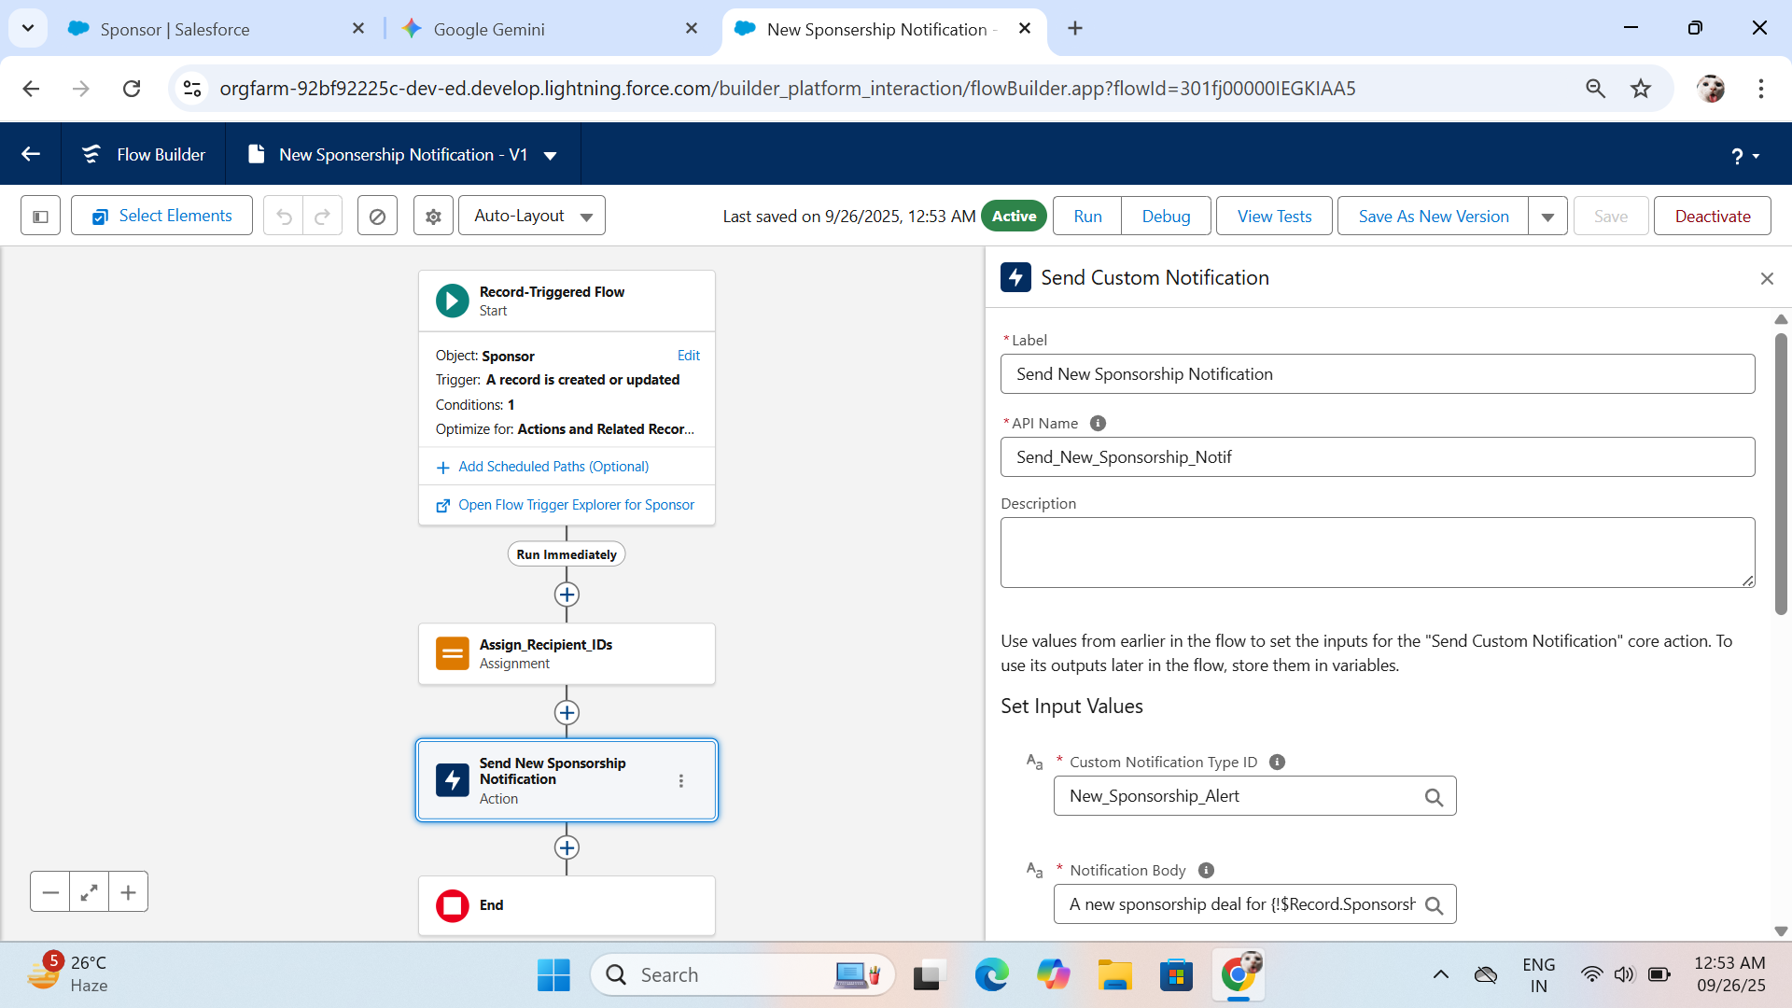

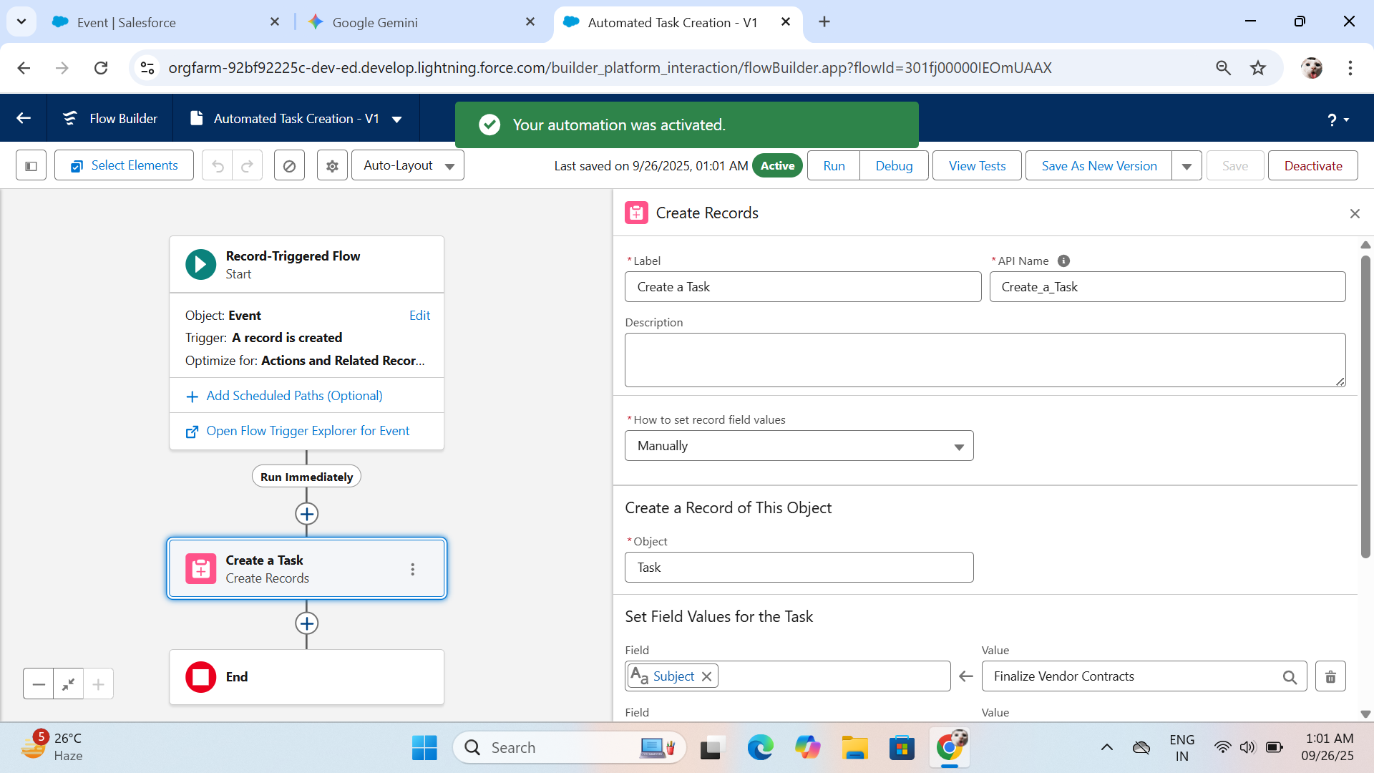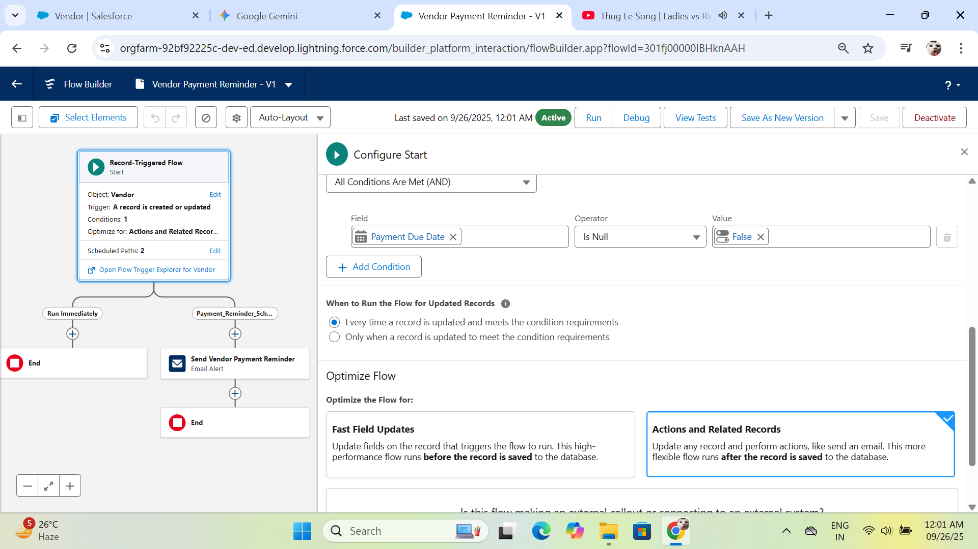

#### Approval Process (Budget Oversight)

* **Explanation:** A formal approval process was set up to ensure the VP of Event Management reviews and authorizes high-value events.
* **Salesforce Path:** Setup → Quick Find → Approval Processes
* **Procedure & Configuration:**
  + **Object:** **Event**.
  + **Entry Criteria:** Set to trigger when a condition is met (e.g., Budget is greater than a certain threshold).
  + **Approver Assignment:** Configured to **"Automatically assign to approver(s)"** using the **VP of Event Management** **Role**.

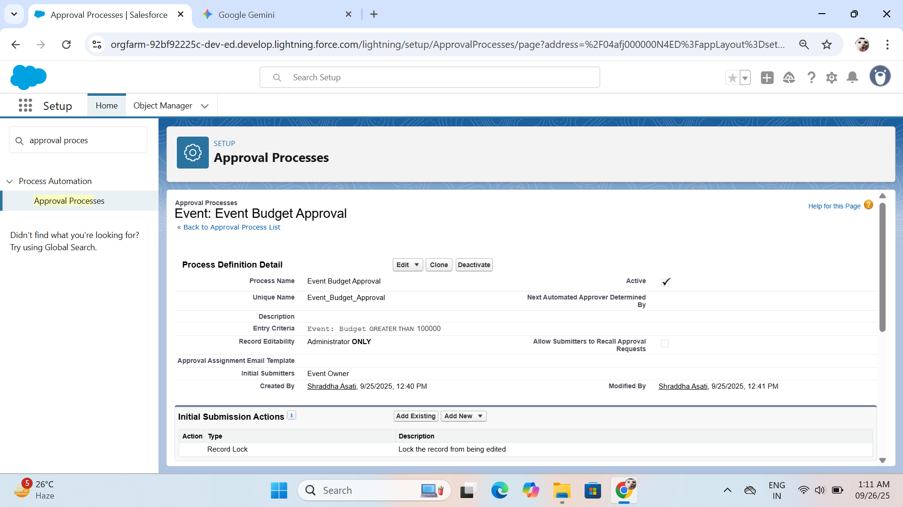

## Email Alerts

| **Detail** | **Description** |
| --- | --- |
| **Explanation** | A reusable action component that sends an email using a predefined template. It's configured once and called by any automation tool (Flow, Approval Process). |
| **Salesforce Path** | Setup → Quick Find → Email Alerts |
| **Project Example** | **Vendor Payment 15-Day Reminder** |
| **Configuration** | **Object:** Vendor. **Email Template:** Custom template referencing Vendor fields. **Recipients:** Set to the **Event Coordinator** **Role**. |
| **Role in Project** | Used within the **Vendor Payment Reminder Flow** (Scheduled Path) to send the notification to the coordinator when the payment date is near. |

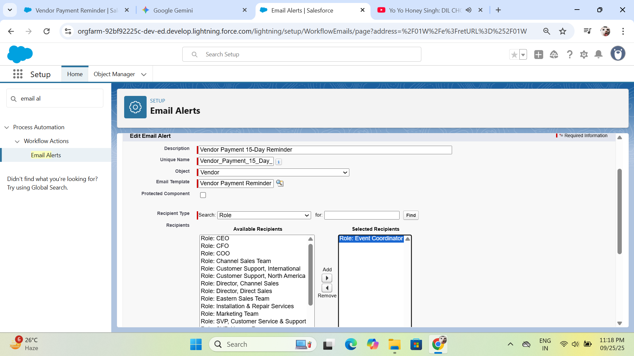

## Field Updates

| **Detail** | **Description** |
| --- | --- |
| **Explanation** | A reusable action that automatically modifies the value of a specific field on a record. It ensures data consistency and reduces manual data entry errors. |
| **Salesforce Path** | Setup → Quick Find → Field Updates |
| **Project Example** | **Update Sponsorship Status to Closed Won** |
| **Configuration** | **Object:** Sponsor. **Field to Update:** Status__c. **New Value:** Set to **Closed Won**. |
| **Role in Project** | Designed to be used in a future flow that confirms sponsorship status based on an integration or an advanced approval step (e.g., automatically marking the deal as Closed Won once the Sponsorship Amount is entered). |

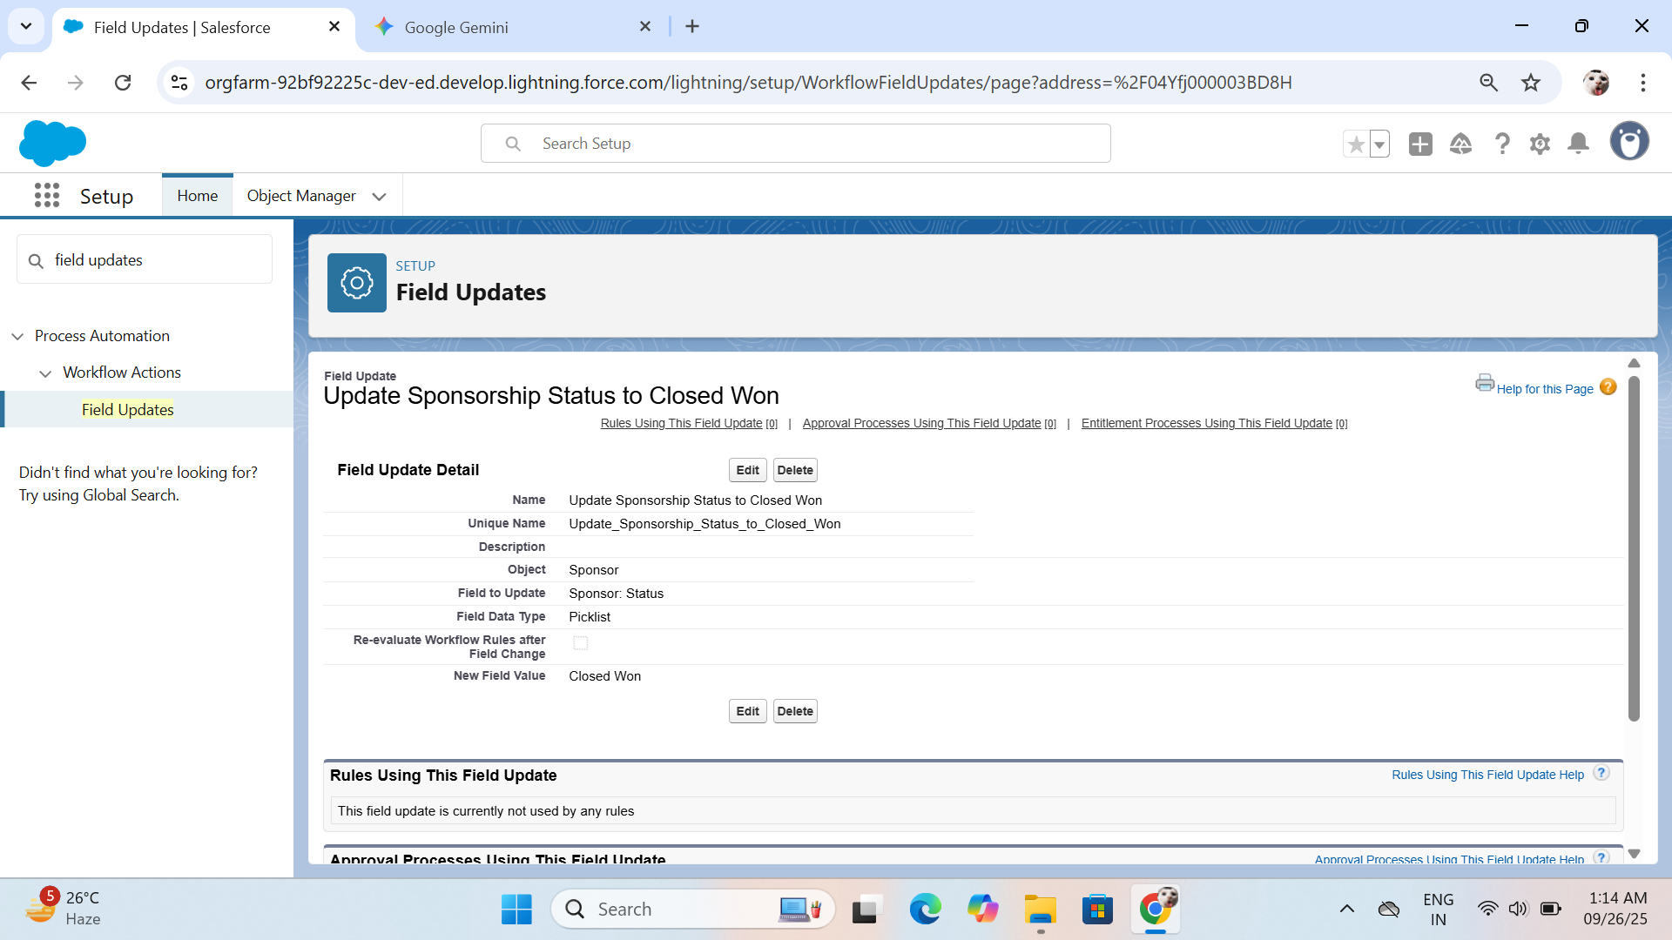

## Tasks (Activity Management)

| **Detail** | **Description** |
| --- | --- |
| **Explanation** | Tasks are standard activity records that track assigned to-do items. In automation, they are created automatically to ensure critical follow-up steps are not missed. |
| **Salesforce Path** | Tasks are configured via the **Create Records** action element within **Flow Builder**. |
| **Project Example** | **Automated Task Creation** (e.g., "Finalize Vendor Contracts") |
| **Configuration** | **Object:** **Task**. **Field Mapping:** Subject, Status, Due Date, and linking the task back to the original **Event** record via the Related To ID ({!$Record.Id}). |
| **Role in Project** | Used in the **Event Creation Flow** to assign the initial setup responsibilities (like hiring vendors) to the event owner immediately after an event record is created. |

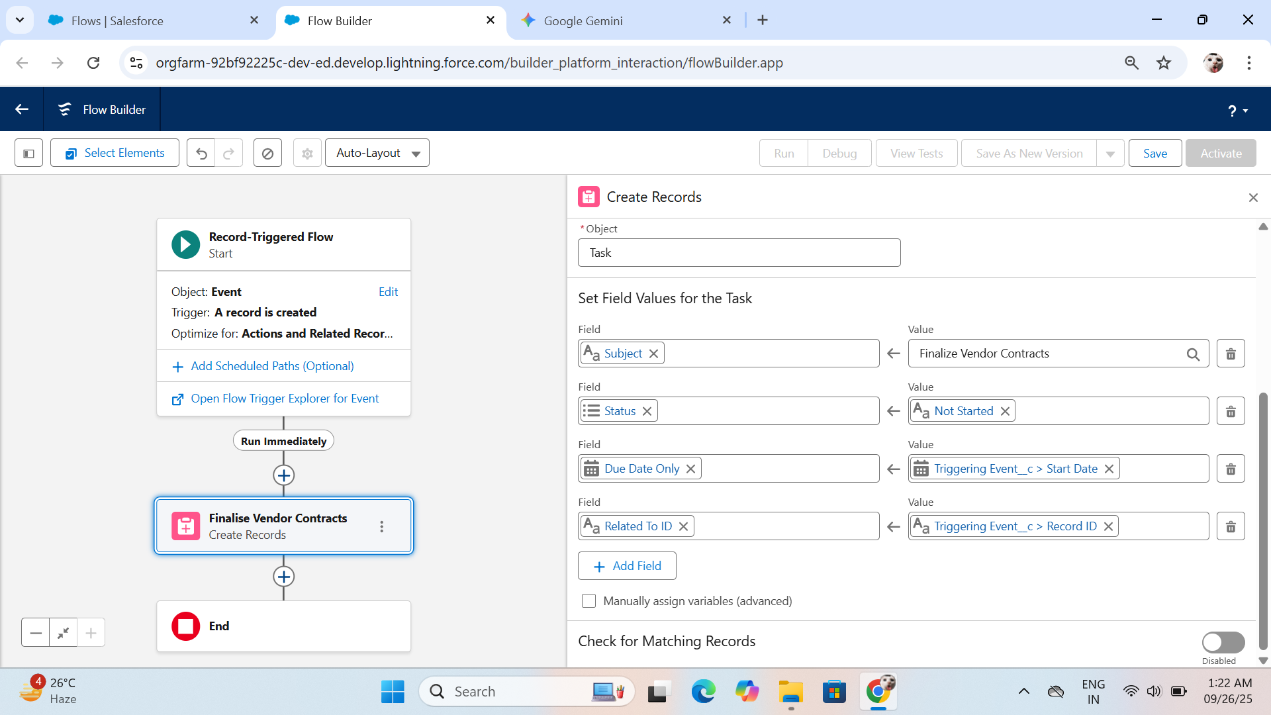

## Custom Notifications

| **Detail** | **Description** |
| --- | --- |
| **Explanation** | A reusable component that sends alerts directly to a user's **Salesforce Bell Icon** and the mobile app. This is ideal for time-sensitive, in-app alerts. |
| **Salesforce Path** | Setup → Quick Find → Custom Notifications |
| **Project Example** | **New Sponsorship Alert** |
| **Configuration** | **Component:** Defined with a Label and unique API Name (e.g., New_Sponsorship_Alert). **Flow Action:** Used in the **New Sponsorship Notification Flow** by specifying the Notification Body, Notification Title, and a collection of **Recipient IDs** (User IDs from the Sponsorship Manager and Event Coordinator roles). |
| **Role in Project** | Used to instantly notify the team (Sponsorship Manager and Event Coordinator) when a high-value sponsorship deal is finalized. |

